PURBANCHAL UNIVERSITY
Assessment – 2010 (ODD)

LEVEL: BE (Electronics & Communication/Computer) I/I
SUBJECT: BEG146ME, Engineering Drawing - I
Full Marks: 40
Pass Marks: 16
TIME: 03:00 hrs.
- Attempt all questions.
- All questions carry marks as indicated in the bracket.
  - Draw an ellipse with major and minor axis of 100 mm and 60 mm respectively. [6]
  - A regular hexagonal lamina, of side 20 mm, rests on one of its sides on HP such that it is perpendicular to VP and inclined to the HP at 45^{O}. Its corner nearest to the VP is 15 mm away from the VP. Draw its projections. [8]
  - Make a complete orthographic drawing (with necessary number of projections) of the following object and dimension it completely. [14]
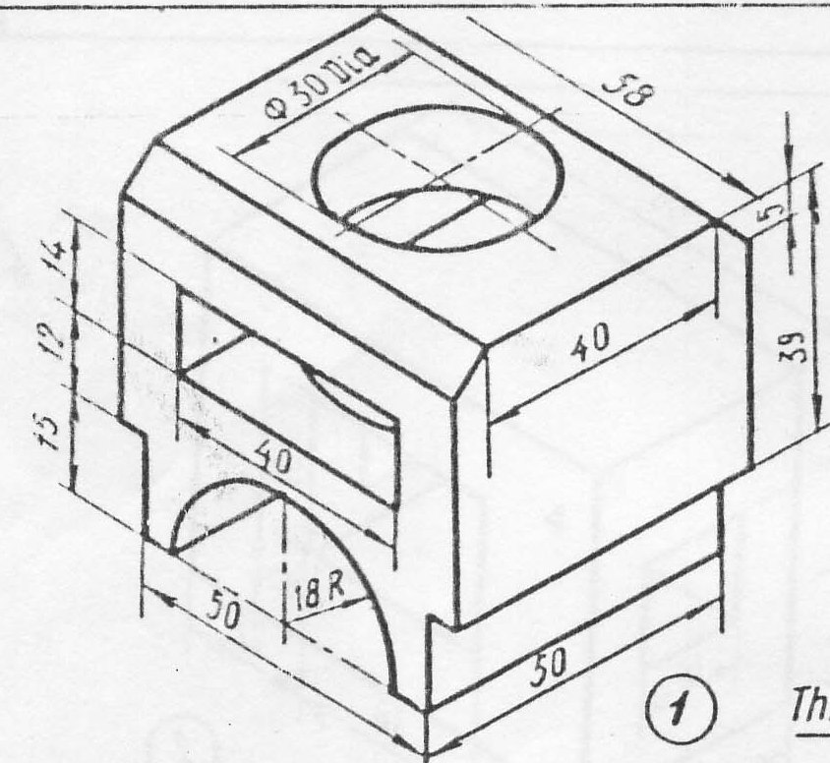

  - Make a complete development of the surfaces of the solid given below, cut by a plane as shown in figure. Find the true shape of the section. [12]
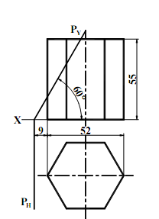 [11]
* * *

